Development Project Features List

Daniel Sokic - 12213229

Travis Frank - 60897899

| **Final Overall System Features** | **Category** | **Possible Points** | **Points** | **Comments / Code Files** |
| --- | --- | --- | --- | --- |
| **Documentation (15 total points)** | | | | |
| Executive Summary (up to 1 page) | Core | 2 | 2 | Listed below |
| System Features (2 pages) | Core | 2 |  | Listed below |
| List of Web and AI sources used | Core | 3 | 3 | Listed below |
| Walkthrough with screenshots (up to 15 pages) | Core | 8 |  | Listed below |
|  | | | | |
| **Hosting (10 total points)** | | | | |
| Running on cloud server | Advanced | 10 |  |  |
|  | | | | |
| **Main/Home Page (up to 14 total points)** | | | | |
| Search for a product by name | Core | 1 | 1 | Able to search products by name |
| Browse products by category | Core | 1 | 1 | Created a dropdown button that filters the products by category |
| List products (by search/browse) | Core | 1 | 1 | Able to search for products by name |
| List products with image | Core | 1 | 1 | Products are listed and have images when clicking on it |
| Page header with menu | Basic | 1 | 1 | Header with links that redirect to other pages |
| Page header shows current logged in user | Basic | 1 | 1 | It displays a welcome message to the user |
| Dynamic products on page based on sales | Basic | 2 |  |  |
| Improved UI (user-friendly, images, etc.) | Basic | 2 | 2 | Main page with improved css by adding buttons and image to background. |
| Product recommendation based on user | Advanced | 4 |  |  |
|  | | | | |
| **Shopping Cart (up to 8 total points)** | | | | |
| Add to shopping cart | Core | 1 | 1 | Add a product from the list to your cart |
| View shopping cart | Core | 1 | 1 | Added a button that redirects user to showcart.jsp with their products |
| Update quantity (with data validation) | Basic | 1 |  |  |
| Remove item from shopping cart | Basic | 1 | 1 | Able to remove items from the shopping cart |
| Improved formatting/UI (e.g. in header bar) | Basic | 1 | 1 | Added some Css to the overall site |
| Cart stored in database between sessions | Basic | 3 |  |  |
|  | | | | |
| **Checkout (up to 9 total points)** | | | | |
| Checkout with customer id | Core | 1 | 1 | When checking out you must input a customer id 1-5. |
| Checkout with payment/shipment info | Basic | 2 |  |  |
| Checkout with data validation | Basic | 2 |  |  |
| Multiple shipments per order supported | Advanced | 2 |  | Note: Requires DB change. |
| Calculate taxes/shipping (by items/state) | Advanced | 2 |  | Note: Requires DB change. |
|  | | | | |
| **Product Detail Page (up to 2 total points)** | | | | |
| Product detail page and item description | Core | 1 | 1 | Listprod.jsp has products and their descriptions when clicking on them |
| Product detail has an image from database | Core | 1 | 1 | When you click a product it also has an image |
|  | | | | |

| **User Accounts/Login (up to 12 total points)** | | | | |
| --- | --- | --- | --- | --- |
| Create user account page | Basic | 2 |  |  |
| Create account with data validation | Basic | 2 |  |  |
| Edit user account info (address, password) | Basic | 2 |  |  |
| Login/logout | Core | 1 | 1 | Login and logout page in login.jsp and logout.jsp |
| Register user/Forgot password email | Advanced | 4 |  |  |
| Page listing all orders for user | Core | 1 | 1 | List all the orders in listorder.jsp |
|  | | | | |
| **Product Reviews (up to 5 total points)** | | | | |
| Ability to enter a review on a product | Basic | 2 | 2 | You can review products |
| Display product review on product detail page | Basic | 1 | 1 | Reviews are visible as well |
| Restrict to one review per user on item purchased | Advanced | 2 |  |  |
|  | | | | |
| **Warehouses/Inventory (up to 5 total points)** | | | | |
| Display item inventory by store/warehouse | Basic | 2 |  |  |
| Edit item inventory by store/warehouse | Advanced | 3 |  |  |
|  | | | | |
| **Administrator Portal (up to 19 total points)** |  |  |  |  |
| Secured by login | Core | 1 | 1 | Login as administrator to get access to the admin page |
| List all customers | Core | 1 | 1 | List all customers In admin |
| List report showing total sales/orders | Core | 1 | 1 | Table of sales report |
| Report with a graph | Advanced | 3 |  |  |
| Add new product | Basic | 2 | 2 | Able to add new product |
| Update/delete product | Basic | 2 | 2 | Able to delete and update |
| Change order status/ship order | Basic | 1 |  |  |
| Upload a photo to file system for product | Advanced | 2 |  |  |
| OR: Upload a photo to database for product | Advanced | 4 |  |  |
| Database restore with SQL script | Basic | 2 |  |  |
| Add/update warehouse, customer | Basic | 2 |  |  |
|  |  |  |  |  |
| **Database System/General** |  |  |  |  |
| Implement some validation using triggers | Advanced | 2 |  |  |
| Use AJAX for some pages | Advanced | 4 |  |  |
| User interface and navigation/usability |  | Up to 5 |  |  |
| *Others (your suggestions)* |  | Up to 5 |  |  |
|  |  |  |  |  |
|  |  |  |  |  |
|  |  |  |  |  |
|  |  |  |  |  |
| **Total: (out of 50 with maximum of 10 bonus marks. i.e. 60 points out of 50 is max.)** |  |  |  |  |

**Documentation:**

**Executive Summary:**

This project is a web-based e-commerce system designed to support interactions between customers and administrators. It is implemented using JSP (JavaServer Pages), with a modular structure enabling scalability and ease of maintenance. The application integrates user authentication, product catalog management, and order processing, while also supporting administrative control over products and transactions. A user can login (those users are stored in the database) and search through the products and view them. Each product has a page with the title, price, description, and some have pictures. Users can also leave reviews of a product on this page and view existing reviews as well. There is also a button that allows users to add it to their cart which will redirect them to the cart page. Inside the cart page the user can check out and then pay for their order by entering their customer id. Alternatively, they can remove things from the cart and go back to the shop page as well. Users in the database can login and get access to the admin page. Once logged in their name will be displayed in the header confirming who is currently logged in. In the admin page users can add/update/delete products from the grocery store. There are also reports that list all the customers and displays the total sales report by day. Another page called Order lists all the orders that have been placed and lastly there is a logout function. The layout consists of a header with a menu that allows users to switch between pages seamlessly and pages containing buttons for adding to carts, submitting reviews, or removing from carts. The formatting is clean and is intuitive for new users.

### **System Features**

#### 1. User Features

* Login and Authentication:
  + Users can log in via login.jsp, which verifies credentials using validateLogin.jsp.
  + Sessions are managed for authenticated users, with a logout feature (logout.jsp) to ensure security.
* Product Browsing and Search:
  + listprod.jsp dynamically displays available products, fetching details from the database.
* Product Reviews:
  + Product.jsp allows the logged in user to review and read reviews on the product page
* Cart Management:
  + Users can add items to their cart (addcart.jsp), view the cart's contents (showcart.jsp), and proceed to checkout.
  + The cart system integrates seamlessly with user accounts to track items.
* Order Management:
  + Orders can be reviewed and placed through order.jsp and checkout.jsp.
  + listorder.jsp allows users to view the past orders.
* Customer Details:
  + Displays the logged in customer’s info

#### 2. Administrative Features

* Product Management:
  + admin.jsp includes tools for:
    - Adding new products.
    - Updating or deleting existing products from the catalog.
* Order tracking:
  + Admins can monitor orders using listorder.jsp.
* Data Management:
  + Administrative pages like jdbc.jsp and loaddata.jsp facilitate database interactions and maintenance tasks.

#### 3. Additional Features

* Dynamic Image Loading:
  + Images are displayed using displayImage.jsp, enhancing user engagement.
* Docker Integration:
  + Docker configuration files (Dockerfile and docker-compose.yml) are included, allowing deployment in a containerized environment. This ensures consistency across different systems.
* Reusable Components:
  + Shared resources like header.jsp, css, and img improve code reusability and maintain a consistent interface.
* Validation and Error Handling:
  + Input validation (e.g., auth.jsp) ensures data integrity and prevents invalid entries.
  + Robust error handling mechanisms maintain system reliability.

#### System Strengths

1. Modular Design:
   * Independent modules for user and admin functions improve maintainability.
2. Scalability:
   * Dockerized deployment supports scalability in production environments.
3. User-Friendly Interface:
   * Intuitive navigation and clear features enhance user experience.
4. Security:
   * Session management and input validation reduce vulnerabilities.

**Sources Used:**

Lab 8 solutions

ChatGPT

Github Copilot

**Walkthrough with screenshots:**

Here is the main page when first prompted without logging in 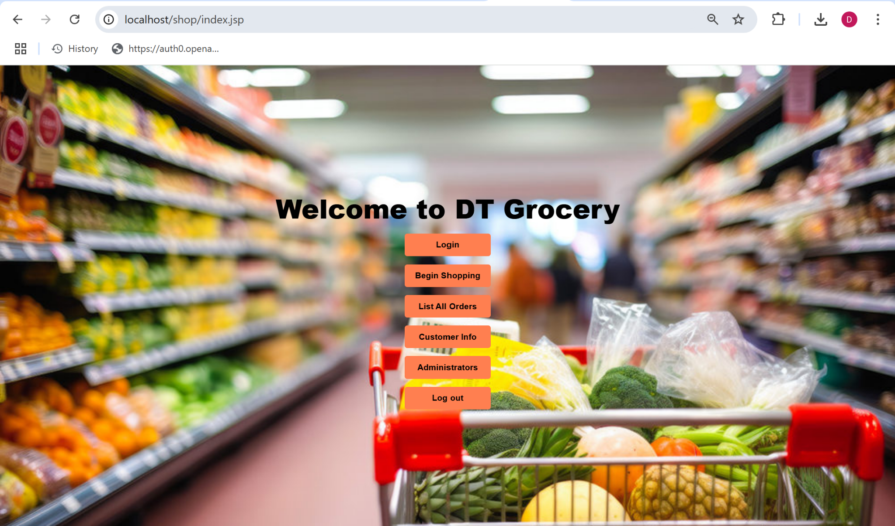

When you log in there is a button added at the bottom that displays who is logged in. This feature of who is logged in will be continually used in the header for all the other pages.

Here is the user arnold logging in with his password (test) from the database

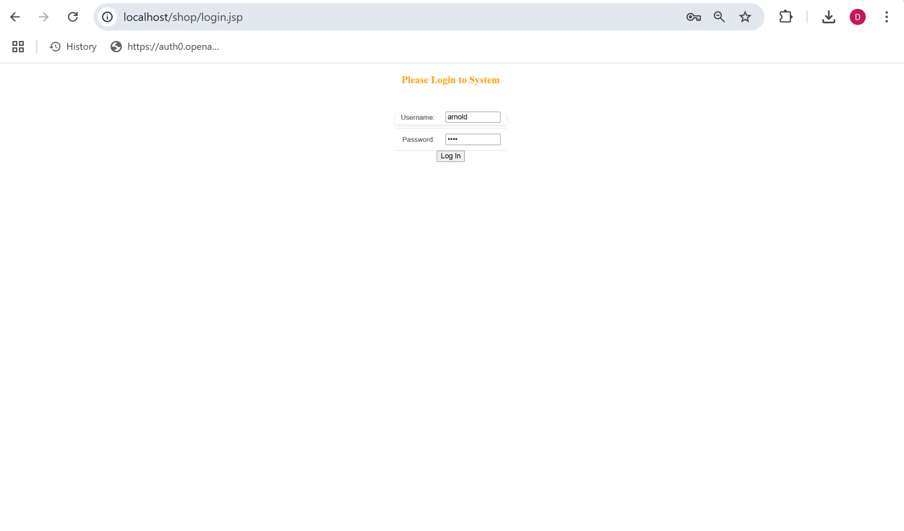

And here is the main page when arnold is logged in.

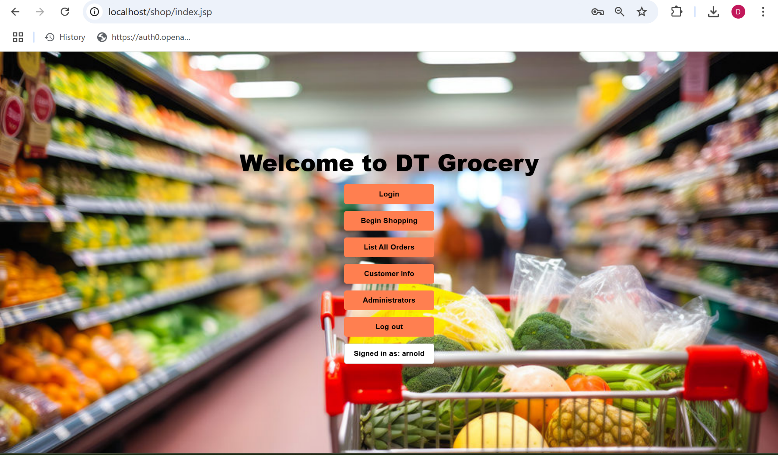

Clicking on the first button Begin shopping, it will redirect you to the list of products with their names, price, and categories.

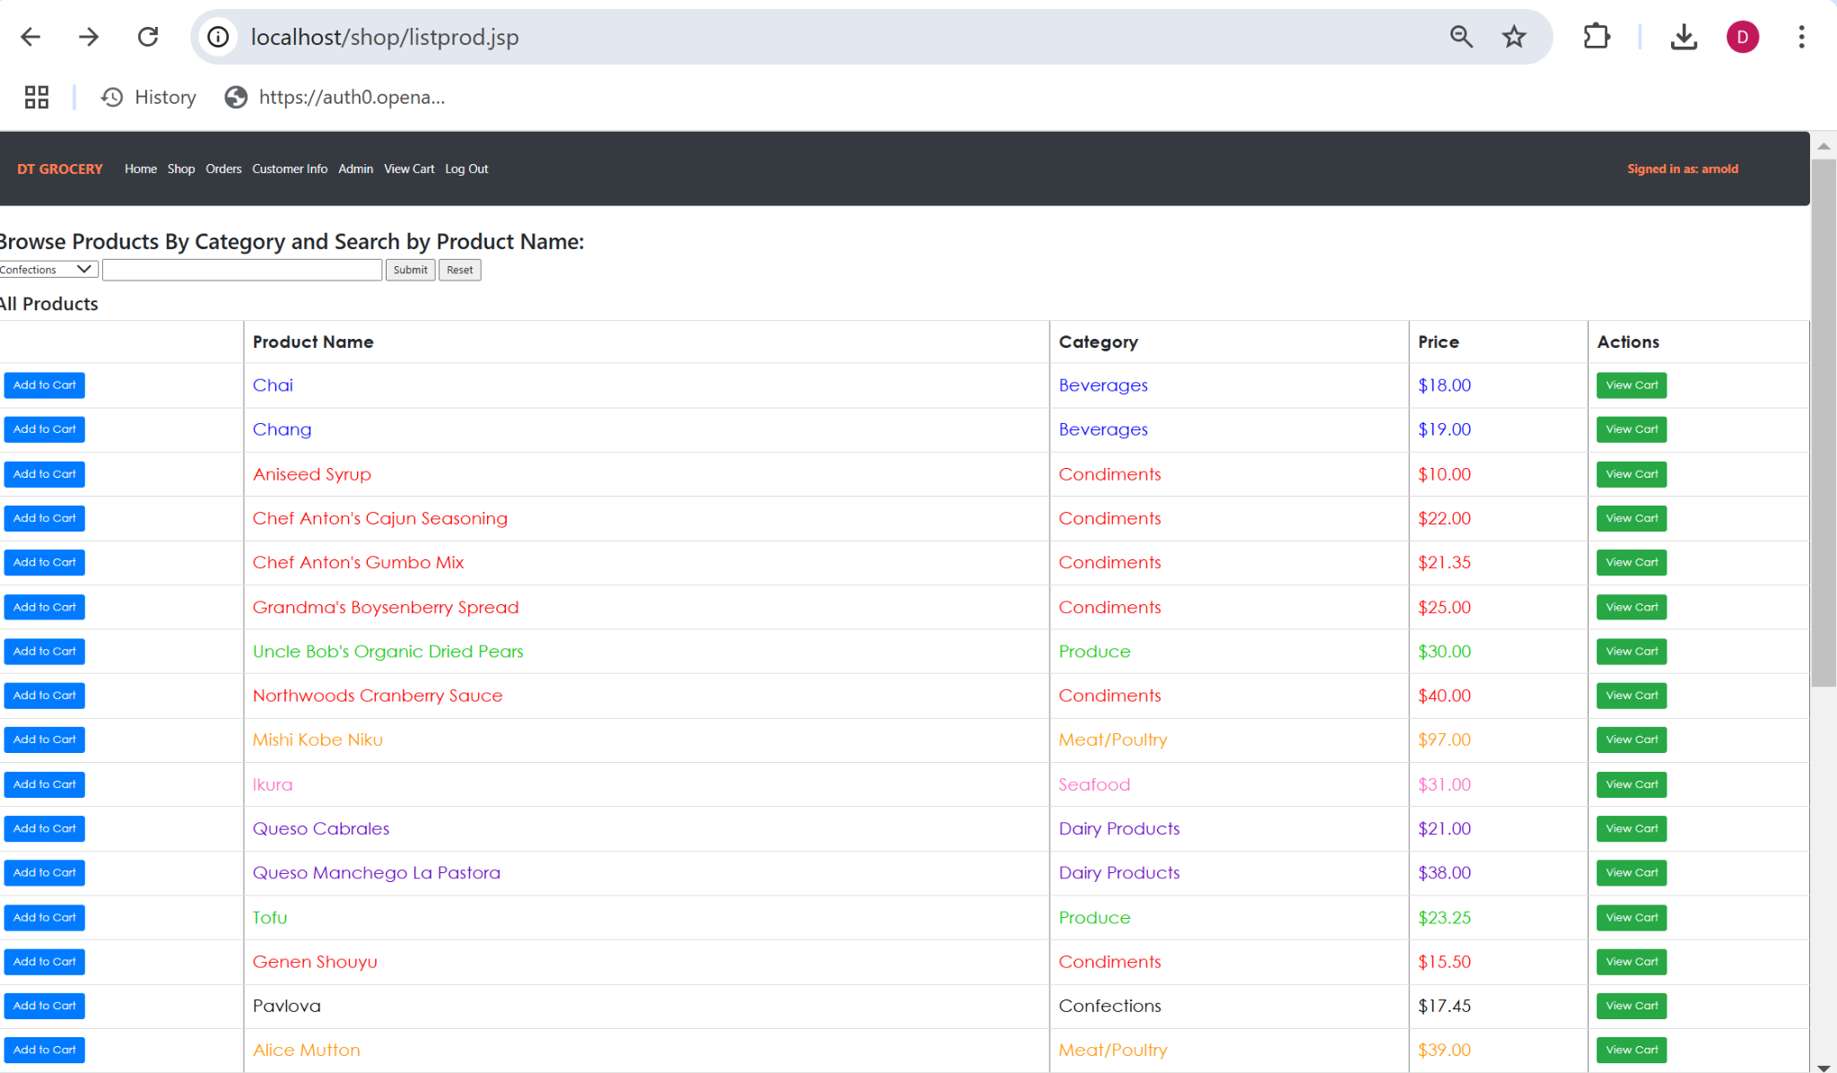

You can search products by name to look for a specific one. Here I will search for Chai.

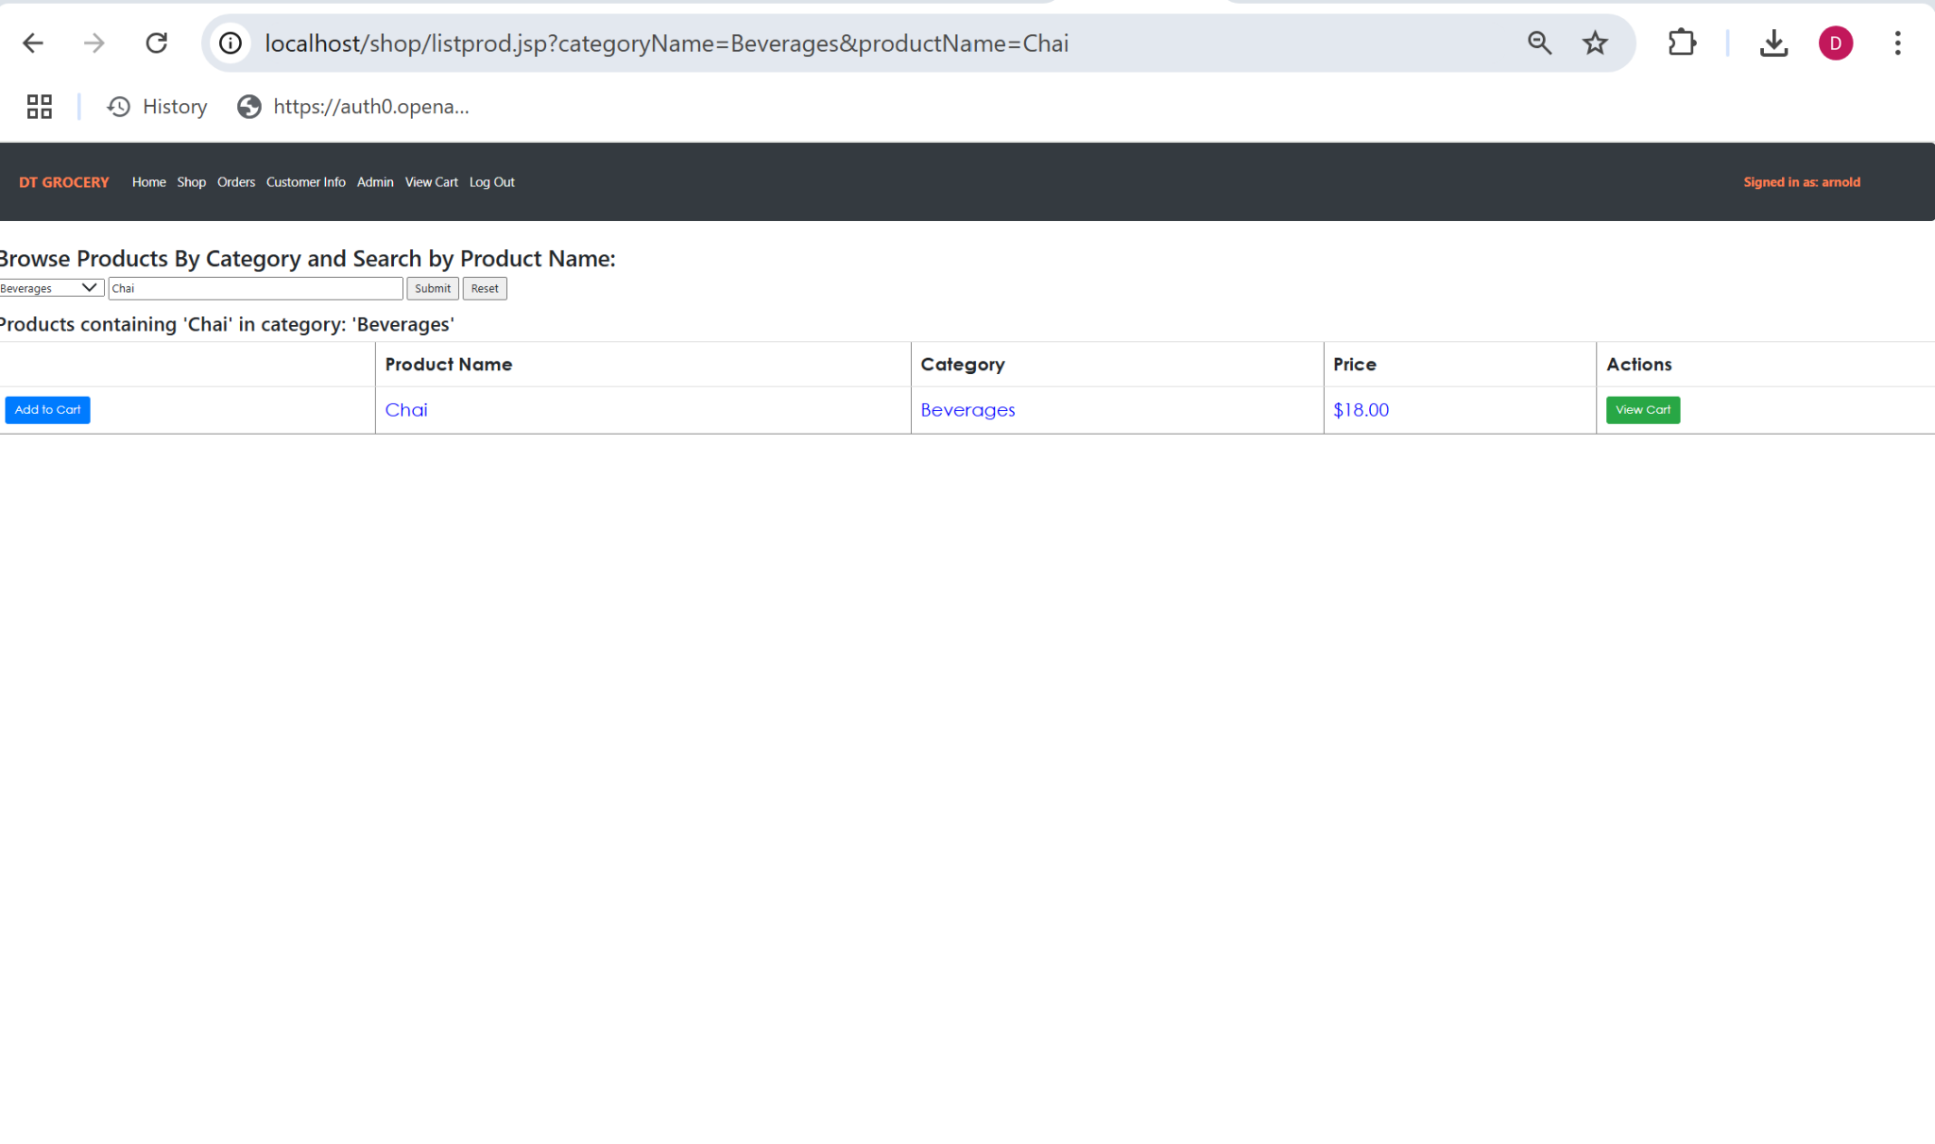

You are also able to filter products by their category by selecting the category in the dropdown menu beside the search bar. Here is an example of filtering by condiments.

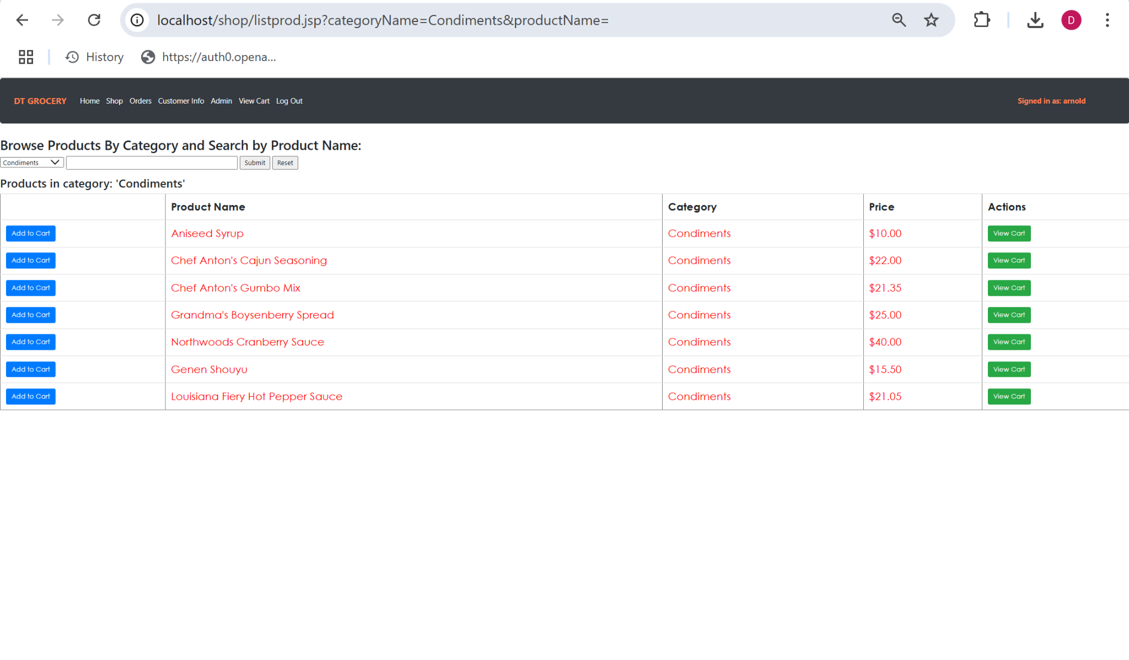

You can click on the product name which will redirect you to its page that displays more information alongside a review option. When I click on the product name chai I am redirected to this page.

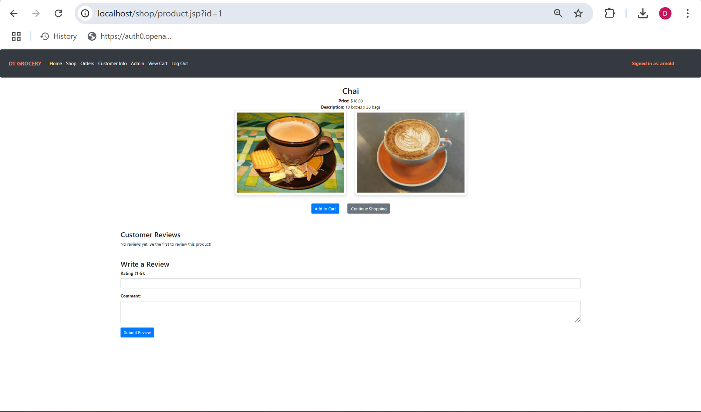

A user is able to leave a review with a rating and comment which will then be visible to the user.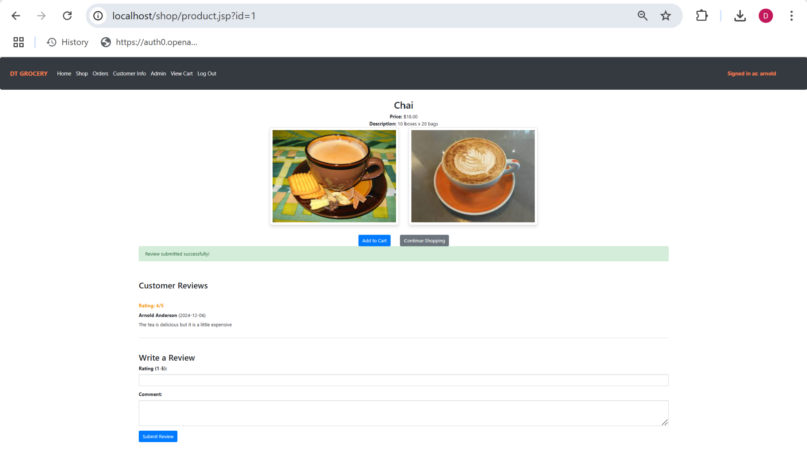

The user is then able to add to the cart or continue shopping and go back to the product page. Here I will add chai to the cart which will then redirect me to the cart page.

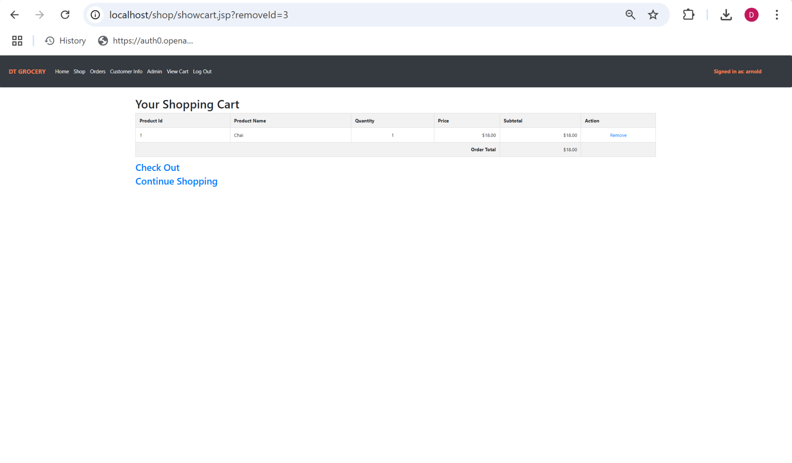

You can also remove it from your cart and make it empty. Here I will remove chai from the cart.

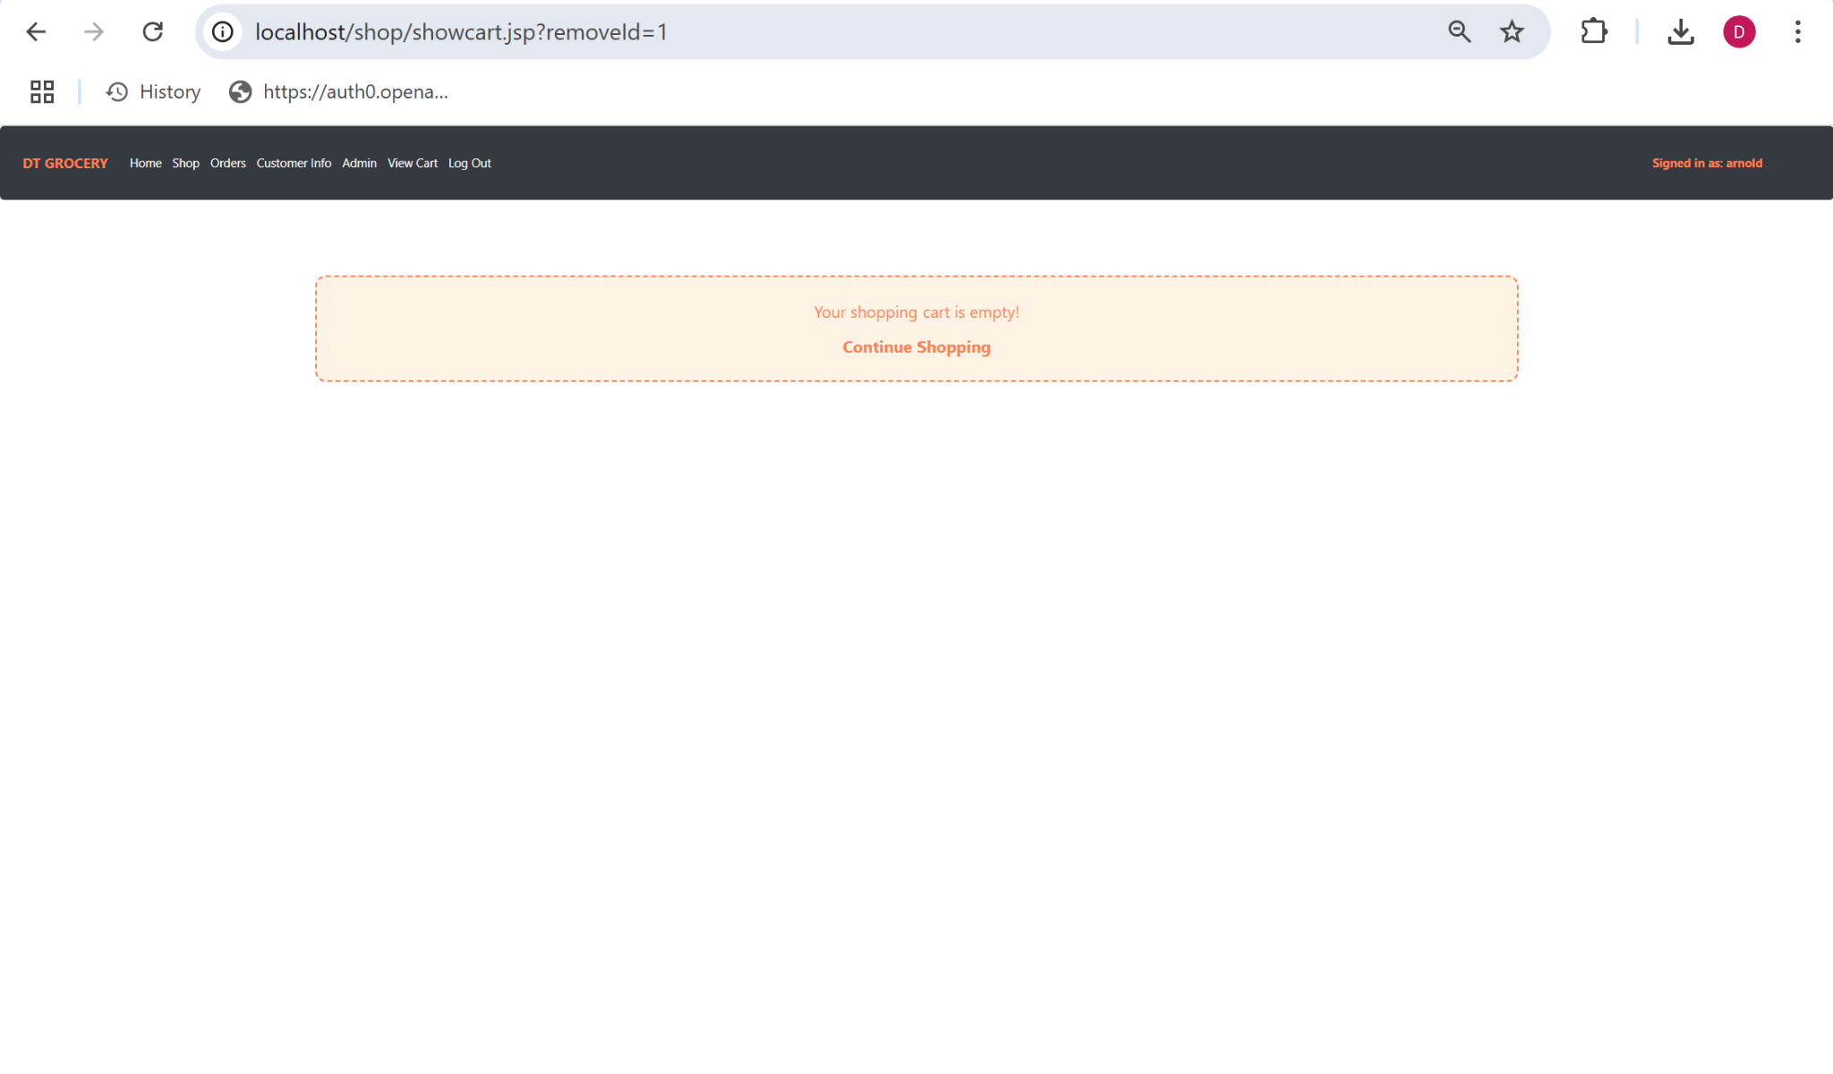

When you have an item in your cart and proceed to checkout, the user will enter their customer id (arnold’s is 1) and then it confirms the order and this is displayed.

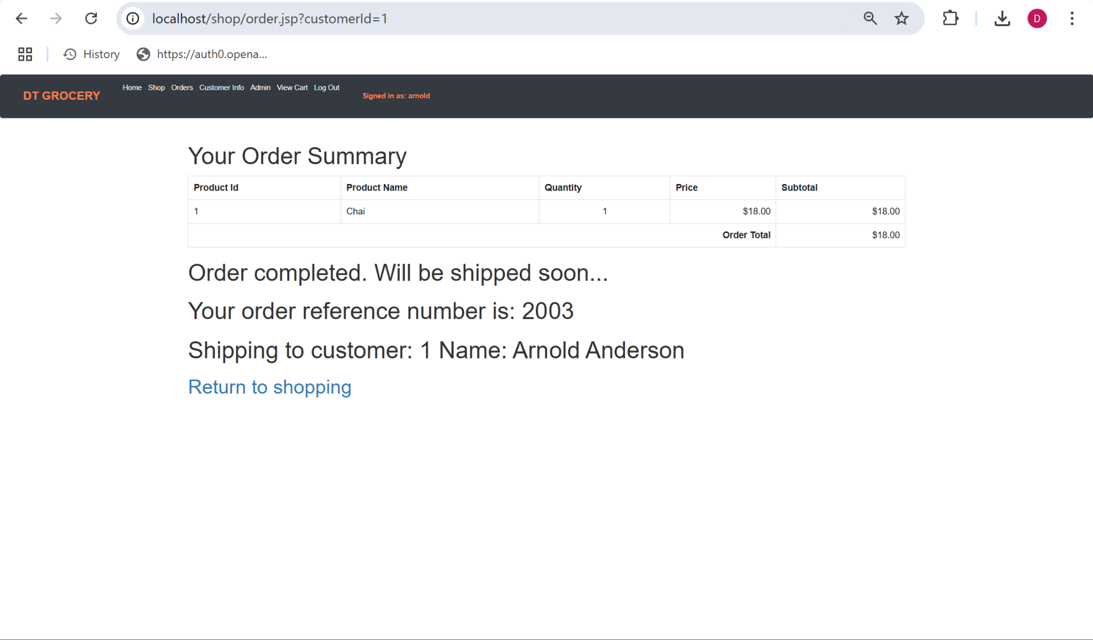

When the “Orders” link or “List All Orders” button is pressed, it takes you to a page with all of the previous customer orders.  
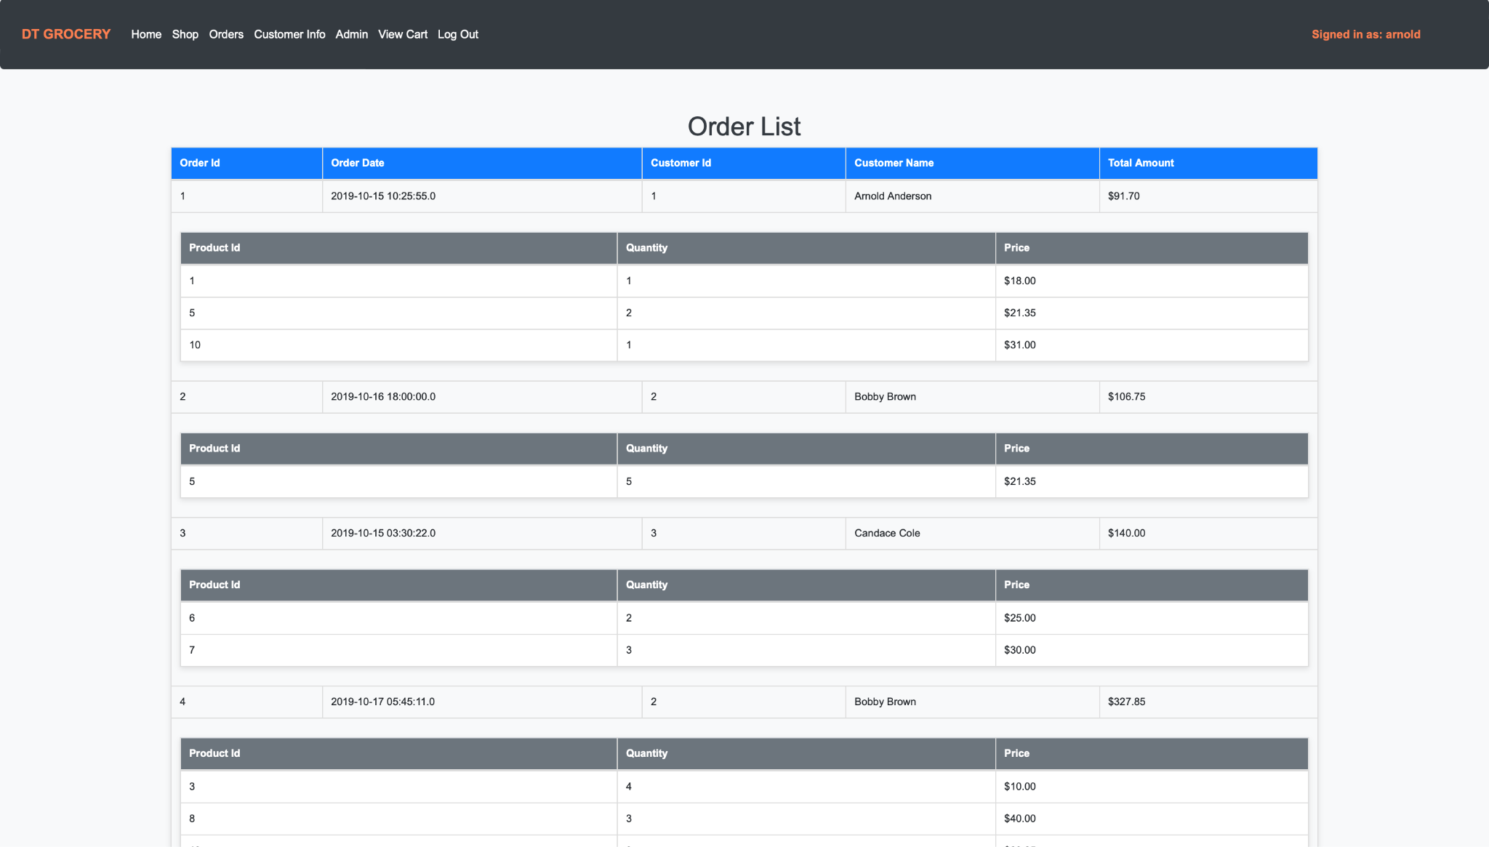

When pressing the “Customer Info” link in the header or main page, the user is taken to a page that displays their information.

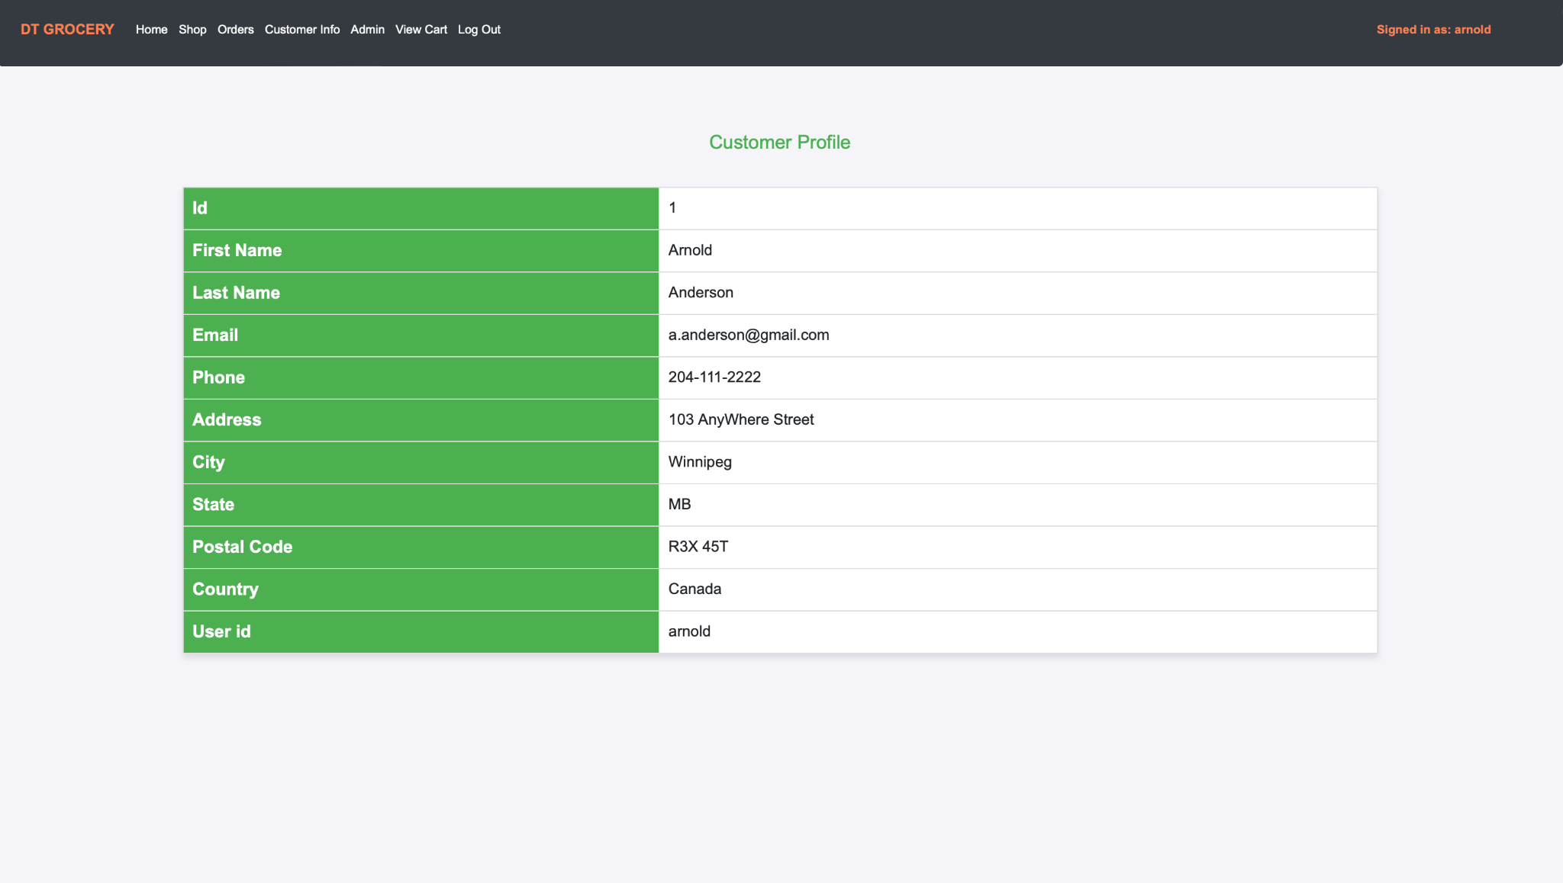

The Admin portal allows the logged in user to Add/Update/Delete products from the product inventory. It also displays the total sales by date and all customers of the store.

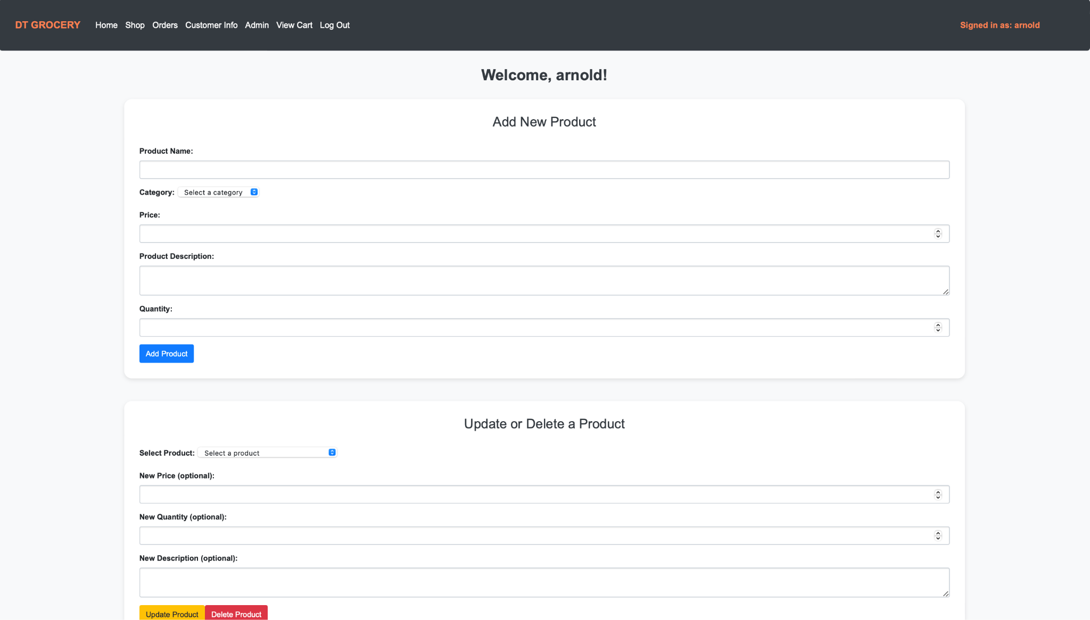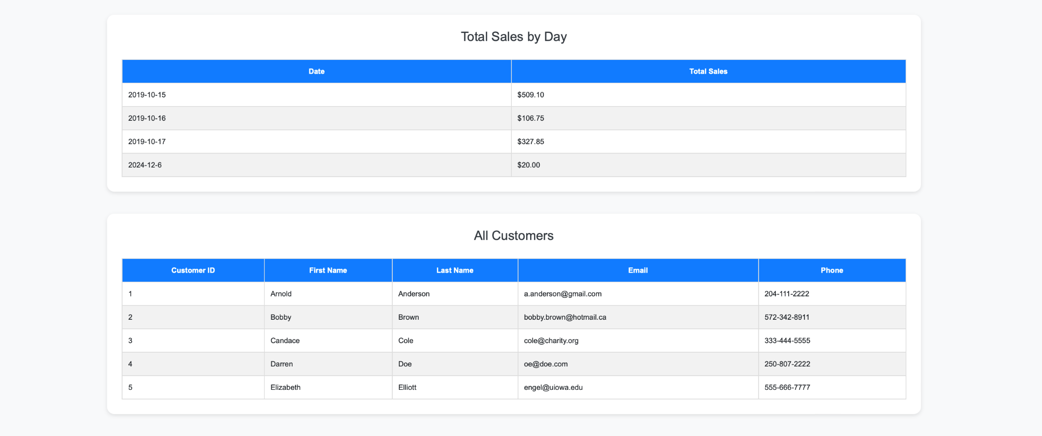

Here is a demo video of the admin page using the add, update, and delete function (There would be too many screenshots so we made a video, below is the unlisted youtube video link that demonstrates the functionality of these features).

<https://youtu.be/pUe9Z7e1M4E>

Here is the url to the site

<http://localhost/shop/>

And here are the user names and passwords for users

Username: Password:

arnold test

bobby bobby

candace password

darren pw

beth test